**PIZZA PROJECT – DATA ANALYTICS**

* **KPI’s QUERIES:-**

**1). TOTAL REVENUE :-** SELECT SUM(total_price) AS Total_Revenue FROM pizza_sales;

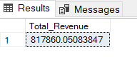

**2). AVERAGE ORDER VALUE :- SUM OF TOTAL PRICE(TOTAL_REVENUE) / DISTINCT COUNT OF ORDER_ID**

SELECT SUM(total_price) / COUNT(DISTINCT order_id) AS Avg_Order_Value FROM pizza_sales;

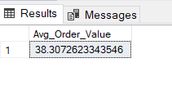

**3). TOTAL PIZZAS SOLD :-** SELECT SUM (quantity) AS Total_Pizzas_Sold FROM pizza_sales;

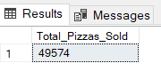

**4). TOTAL ORDERS :-** SELECT COUNT(DISTINCT order_id) AS Total_Orders FROM pizza_sales;

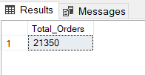

**5). AVERAGE PIZZAS PER ORDER :- TOTAL NO. OF PIZZAS SOLD / TOTAL NO. OF ORDERS**

SELECT CAST(CAST(SUM(quantity) AS DECIMAL(10,2))/ CAST(COUNT(DISTINCT order_id) AS DECIMAL(10,2)) AS DECIMAL(10,2))AS Avg_Pizzas_Per_Order FROM pizza_sales;

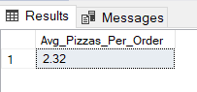

**6). TREND FOR DAILY ORDERS QUERY AND HOURLY ORDERS IN A DAY :-**

SELECT * FROM pizza_sales;

-- Daily Trends

SELECT DATENAME (DW, order_date) AS Order_Day,

COUNT (DISTINCT order_id) AS Total_Orders

FROM pizza_sales

GROUP BY DATENAME (DW, order_date)

-- Hourly Trends

SELECT DATEPART (HOUR, order_time) AS Order_Hour,

COUNT (DISTINCT order_id) AS Total_Orders

FROM pizza_sales

GROUP BY DATEPART (HOUR, order_time)

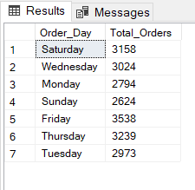 ORDER BY DATEPART (HOUR, order_time)

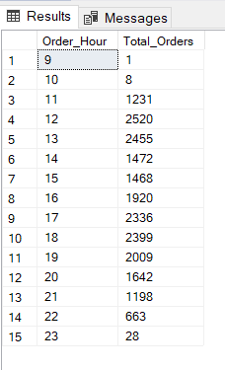

**7). PERCENTAGE OF SALES BY PIZZA CATEGORY AND PIZZA SIZE:-**

-- Percentage of sales by Pizza Category

SELECT pizza_category, SUM (total_price) AS Total_Sales,

SUM (total_price)*100 / (SELECT SUM (total_price) FROM pizza_sales WHERE MONTH(order_date) =1) AS PCT

FROM pizza_sales

WHERE MONTH(order_date)=1

GROUP BY pizza_category

-- Percentage of sales by Pizza Size

SELECT pizza_size, SUM (total_price) AS Total_Sales, SUM (total_price)*100 /

(SELECT SUM (total_price) FROM pizza_sales) AS PCT

FROM pizza_sales

GROUP BY pizza_size

ORDER BY PCT DESC

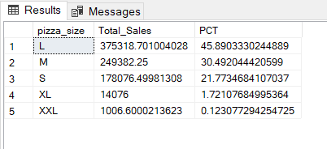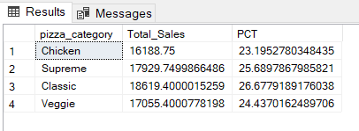

**8). TOP 5 BEST AND WORST SELLERS BY TOTAL PIZZAS SOLD :-**

-- Top 5 Best Sellers

SELECT TOP 5 pizza_name, SUM (quantity) AS Total_Pizzas_Sold

FROM pizza_sales

GROUP BY pizza_name

ORDER BY SUM (quantity) DESC

-- Top 5 Worst Sellers

SELECT TOP 5 pizza_name, SUM (quantity) AS Total_Pizzas_Sold

FROM pizza_sales

GROUP BY pizza_name

ORDER BY SUM (quantity) ASC

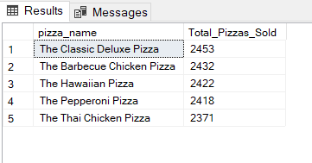

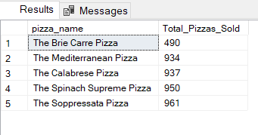

**NOTE :-**

If you want to apply the Month, Quarter, Week filters to the above queries you can use WHERE clause. Follow some of below examples

SELECT DATENAME(DW, order_date) AS order_day, COUNT(DISTINCT order_id) AS total_orders

FROM pizza_sales

WHERE MONTH(order_date) = 1

GROUP BY DATENAME(DW, order_date)

*\*Here MONTH(order_date) = 1 indicates that the output is for the month of January. MONTH(order_date) = 4 indicates output for Month of April.*

SELECT DATENAME(DW, order_date) AS order_day, COUNT(DISTINCT order_id) AS total_orders

FROM pizza_sales

WHERE DATEPART(QUARTER, order_date) = 1

GROUP BY DATENAME(DW, order_date)

*\*Here DATEPART(QUARTER, order_date) = 1 indicates that the output is for the Quarter 1. MONTH(order_date) = 3 indicates output for Quarter 3.*